Hotel AI Revenue Analysis
NAME: CH.Sri Thejaswi
DATE: 6-03-2026
1. Project Overview
The Hotel AI Revenue Analysis project focuses on analyzing hotel booking and revenue-related data to understand customer booking patterns and hotel performance. The project uses data visualization techniques to convert raw data into meaningful insights. An interactive dashboard is created using Power BI to analyze key metrics and identify revenue trends in the hotel industry.
2. Objectives of the Project
To analyze hotel booking and revenue data.
To identify patterns in customer bookings.
To understand factors affecting hotel revenue.
To visualize data through interactive dashboards.
To generate insights that help improve hotel performance.
3. Tools and Technologies Used
Microsoft Excel – Used for reviewing and understanding the dataset.
Power BI – Used to create dashboards and visualizations.
Data Visualization Techniques – Used to present data using charts and graphs.
4. Work Completed
During the internship, the following tasks were completed:
Reviewed the hotel booking dataset.
Cleaned and organized the data for analysis.
Imported the dataset into Power BI.
Created key performance indicators (KPIs) such as bookings and occupancy rate.
Developed visualizations to analyze booking behavior and revenue-related patterns.
Designed an interactive dashboard to represent the insights
5. Dashboard Overview
An interactive dashboard titled “Hotel Operational Efficiency & Booking Behavior Analysis” was developed using Power BI. The dashboard provides a visual representation of important metrics related to hotel bookings and operational performance. The dashboard enables users to analyze booking behavior, market segments, and customer trends through multiple visual elements and filters.
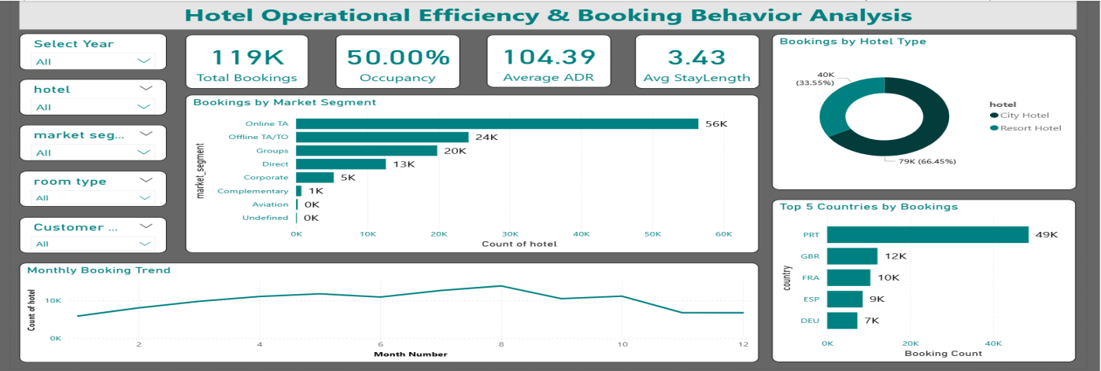
6. Dashboard Components
KPI Indicators
The dashboard includes key performance indicators that summarize important metrics:
Total Bookings: 41K total bookings recorded in the dataset.
Occupancy Rate: 50% occupancy indicating the percentage of rooms occupied.
Average Daily Rate (ADR): 117.12 representing the average revenue generated per room.
Average Stay Length: 3.57 days representing the average duration of customer stay.
These KPIs provide a quick overview of the hotel’s operational performance.
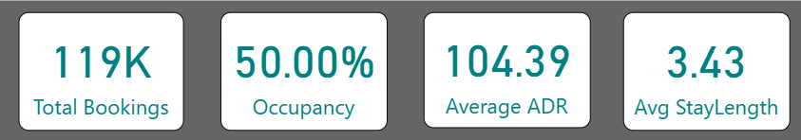
Bookings by Market Segment
A bar chart shows the distribution of bookings across different market segments.
The analysis indicates that Online Travel Agencies (Online TA) contribute the highest number of bookings, followed by Group bookings and Offline Travel Agencies. Other segments such as Direct bookings, Corporate bookings, Complimentary, and Aviation contribute smaller portions.
This visualization helps understand which booking channels generate the most customers.
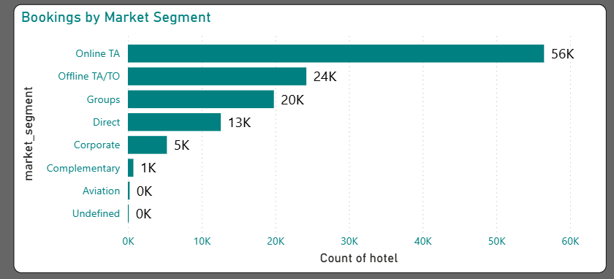
Bookings by Hotel Type
A donut chart compares bookings between City Hotels and Resort Hotels.
The chart shows that Resort Hotels account for a larger share of bookings (around 67%), while City Hotels account for approximately 33%.
This comparison helps understand the popularity of different hotel types among customers.
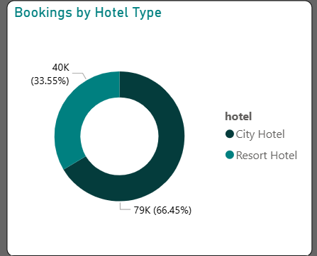

Top 5 Countries by Bookings
A horizontal bar chart displays the top countries from which bookings originate.
The top countries include:
Portugal (PRT)
United Kingdom (GBR)
France (FRA)
Germany (DEU)
Spain (ESP)
Portugal has the highest number of bookings among the listed countries.
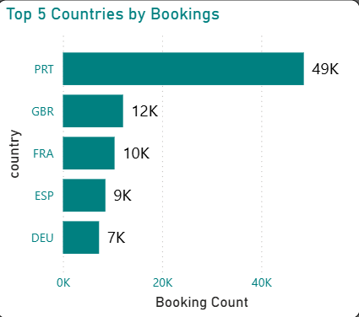

Monthly Booking Trend
A line chart shows the variation in booking counts across different months.
The chart indicates that bookings gradually increase during the first half of the year, reaching a peak around May, after which the bookings show a slight decline in later months.
This visualization helps identify seasonal trends in hotel bookings.
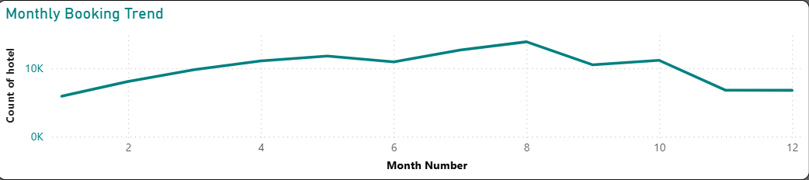
Dashboard Filters
The dashboard also includes interactive filters that allow users to explore the data based on different conditions.
Filters available in the dashboard include:
Year Selection
Hotel Type
Market Segment
Room Type
Customer Type
These filters enable users to customize the analysis according to specific requirements.

7. Key Learnings
Learned how to analyze hotel booking data.
Gained practical experience in Power BI dashboard creation.
Improved understanding of data visualization techniques.
Learned how to convert raw data into meaningful insights.
8. Future Work
Enhance the dashboard with more visualizations.
Add additional analytical insights from the dataset.
Improve dashboard design and layout.
Prepare the final presentation of the project.
9. Conclusion
The Hotel AI Revenue Analysis project helped in understanding hotel booking patterns and revenue-related insights using data visualization. By creating an interactive dashboard in Power BI, meaningful insights were generated that help analyze hotel performance and booking behavior.

